Institute for Science, Ethics and Innovation
The University of Manchester
Williamson Building
Oxford Road
Manchester
M13 9PL
UK

Senator Bernard Sanders, Vermont
United States Senate
Washington, DC 20510-4504

November 30th 2010

INSTITUTE FOR SCIENCE, ETHICS AND INNOVATION – ENDORSEMENT OF THE ‘ETHICAL PATHWAY ACT OF 2010’

The Institute for Science, Ethics and Innovation shares the concerns of Senator Sanders and others that current United States legislation on approvals of pharmaceuticals and biological products has strong potential to encourage applicants for marketing approval to breach long-established ethical standards for the conduct of medical research. The Ethical Pathway Act of 2010 provides an appropriate and fair remedy for this situation by avoiding the need for applicants to unnecessarily repeat clinical trials. Importantly it does so in a manner which protects the financial interests of innovators by creating procedures through which they will receive reasonable and fair fees for sharing regulatory test data.

We believe, therefore, that there are very strong ethical reasons for enacting such legislation, and fully endorse the Ethical Pathway Act of 2010.

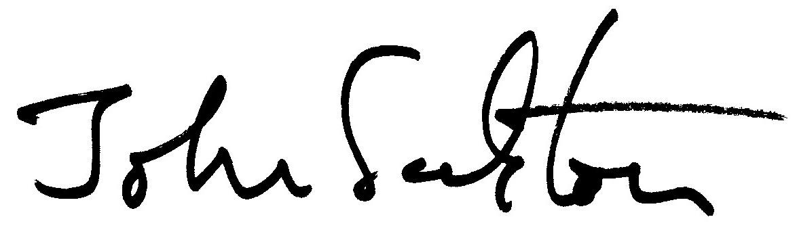

Prof. John Harris Prof. Sir John Sulston

For and on behalf of the Institute for Science, Ethics and Innovation.

